SETTING UP APPLICATION

ENVIRONMENT

|  |  |
| --- | --- |
| Date | 17 November 2022 |
| Team ID | PNT2022TMID45099 |
| Project Name | CUSTOMER CARE REGISTRY |

COLUD ACCOUNT CREATION:

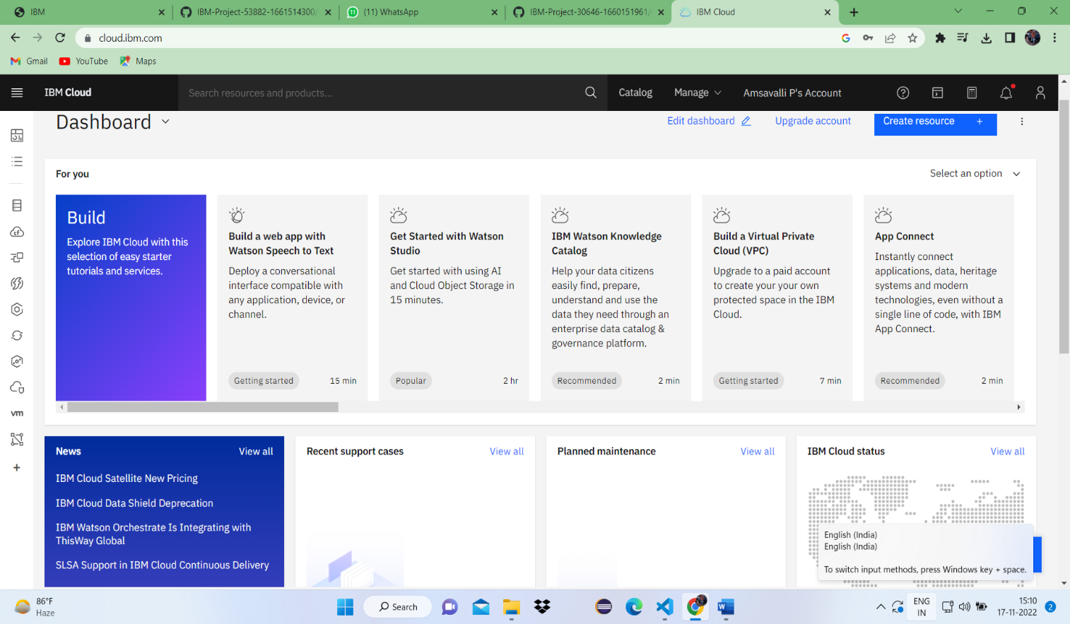

1